**Huawei Talent Portal link:**

[**https://e.huawei.com/en/talent/portal/#/**](%20https:/e.huawei.com/en/talent/portal/%23/)

**Step 1:** Log in to the Huawei Talent portal by clicking on the login button at the top-right corner.

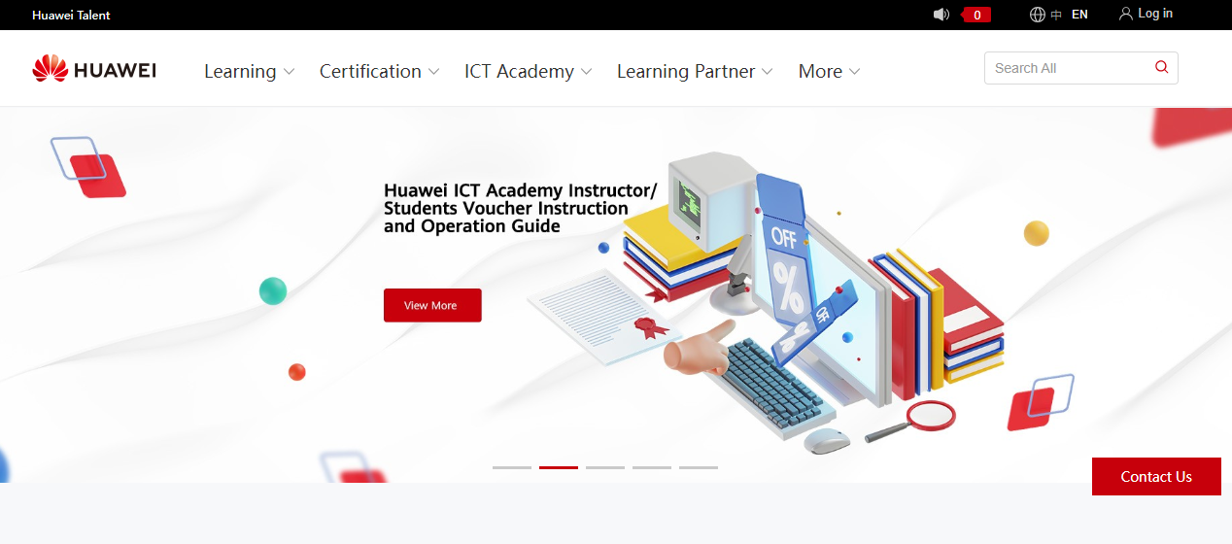

**Step 2:** Register yourself first by clicking on the register button below the red login button.

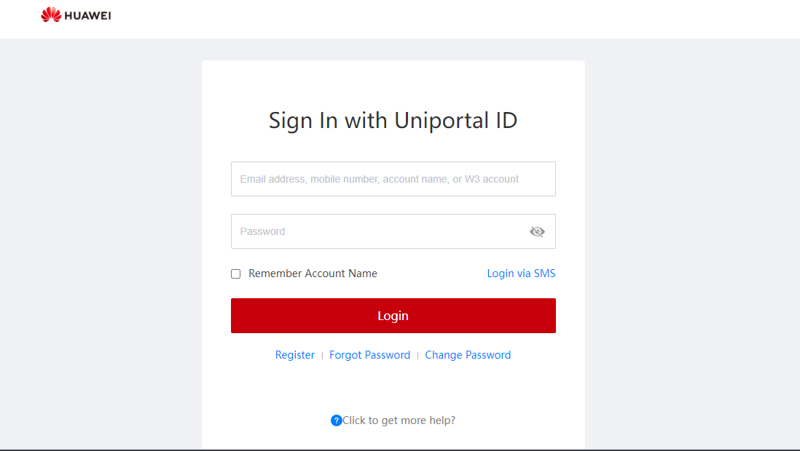

**Step 3:** Register by mobile or by email according to your preference by filling in the following credentials.

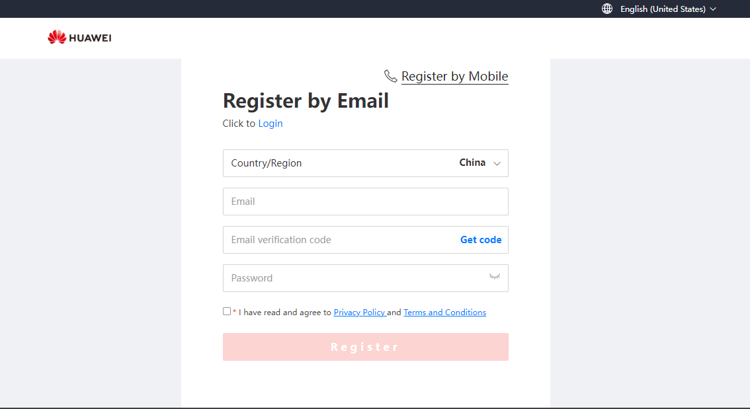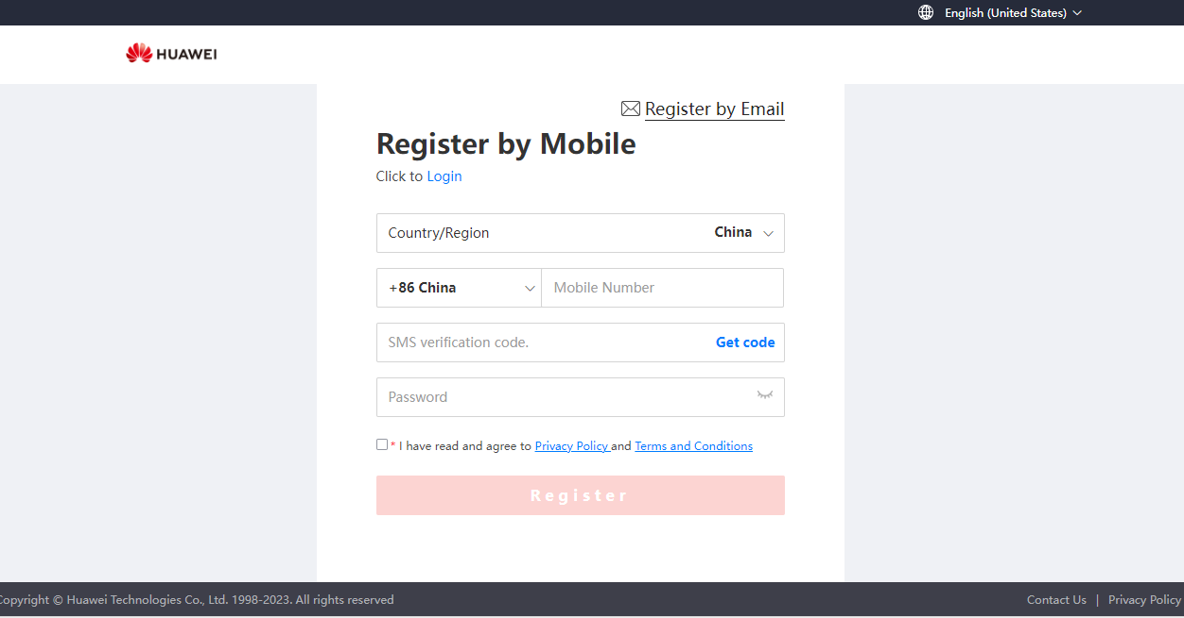

**Step 4:** Login again after successful registration



**Step 5:** After login successfully click on ICT academy and select practice competition.

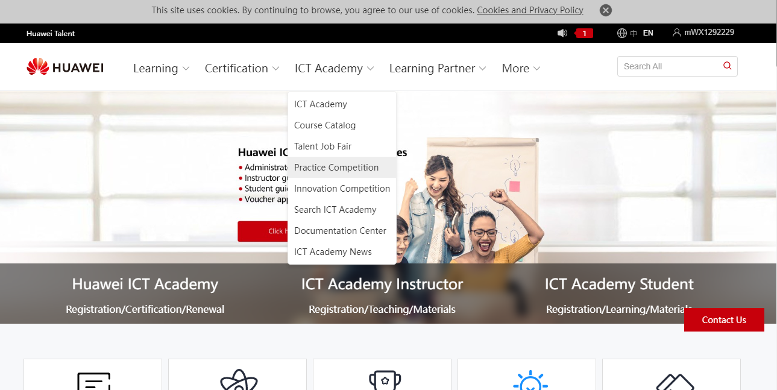

**Step 6:** Now scroll down and select the Middle East and Central Asia region competition in the registration channel section.

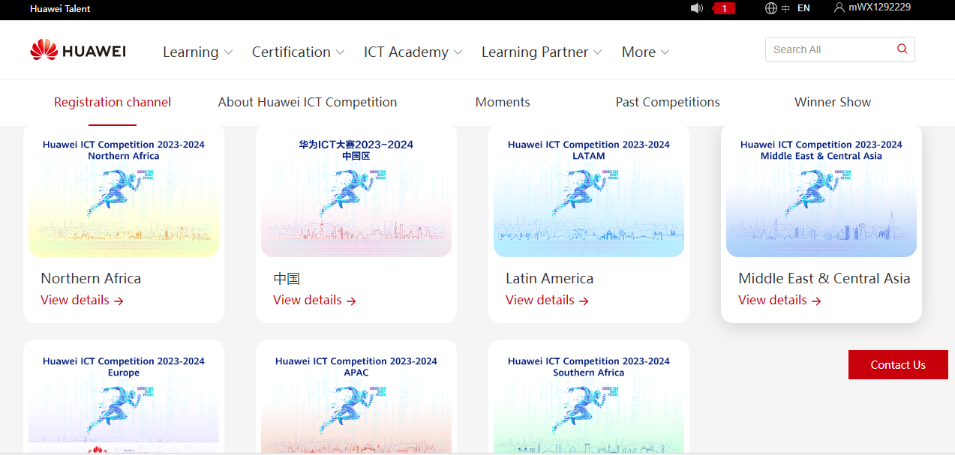

**Step 7:** Now click on competition registration and fill in the credentials and choose the competition track.

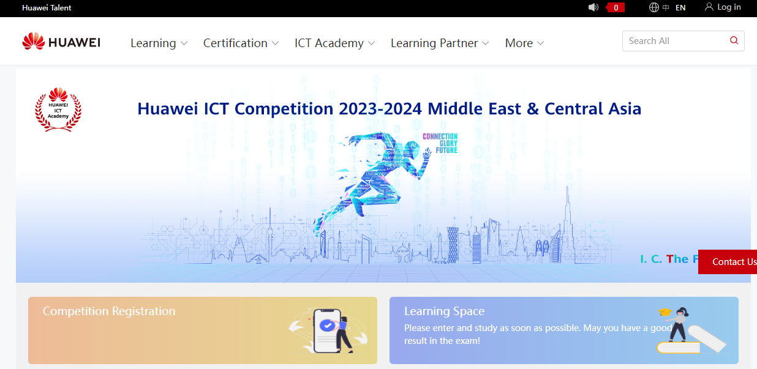

**Step 8:** After successful registration you will see registration successful like the following image given below.

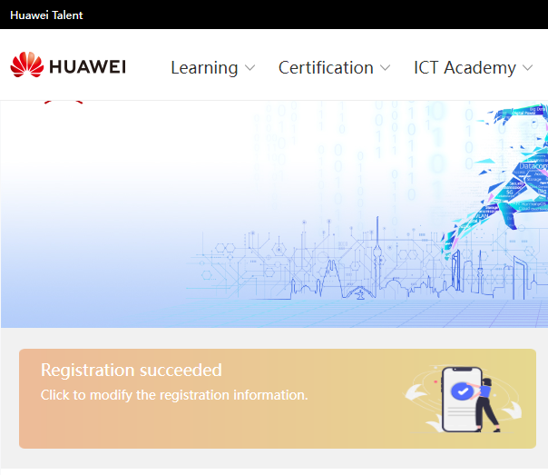

**Step 9:** You can modify the details anytime before deadline and for preparation of competition you can use resources present in learning space.

